& 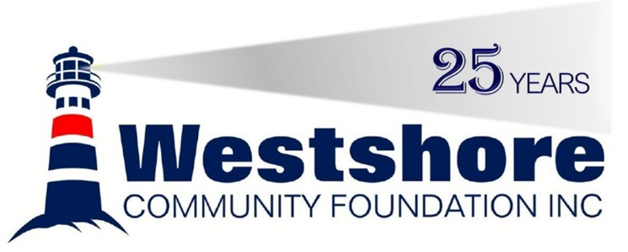
20TH ANNUAL FUNDRAISER GOLF TOURNAMENT

Monday, August 19, 2024

REGISTRATION, BREAKFAST & DINNER – LAKEVIEW RESORT
10:00 AM Registration & Breakfast,
11:00 AM Putting Contest, 12:00 PM Shotgun Start
6:00 PM Dinner & Prizes

GOLF TOURNAMENT – LINKS AT THE LAKE
18 Hole Texas Scramble
Team or Individual Entry Welcome

Entry Fee: $150.00 per person
Includes: Cart, 18 Holes of Golf, Breakfast, Dinner & Prizes

Golfer: | Phone: |  | E-mail:
Golfer: | Phone: |  | E-mail:
Golfer: | Phone: |  | E-mail:
Golfer: | Phone: |  | E-mail:
Please return this form with payment to:
Westshore Community Foundation
Box 395, Gimli, MB R0C 1B0
Or by email to admin@wcf-foundation.ca or phone at 204-642-9796
Please make Cheques payable to “Westshore Community Foundation”
Cash, E-transfer, Debit, Visa and Mastercard are accepted at the Westshore Community Foundation office
The first 36 paid teams will be accepted.

Contact:
Amber Reykdal Tournament Coordinator  Lakeview Resort Gimli  204-642-4425  areykdal@lakeviewresorts.com |  | Darin Lemieux Events Chair  Westshore Community Foundation Inc.  204-290-2200  darin@ronanorth.com

